**Title:- Greenprint : Nature Mapping and Analysis on Alaska region**

**Introduction :**

The project focuses on identifying and analyzing green spaces in urban areas across Alaska. This initiative aims to map natural environments such as parks, forests, and other vegetation within city boundaries, providing crucial insights into their ecological benefits. By understanding the distribution and health of these urban green areas, we can promote sustainable urban planning and biodiversity conservation. The project also helps assess the role of green spaces in improving air quality, mitigating climate impacts, and enhancing the well-being of Alaska's residents. This analysis is vital for preserving the unique natural heritage of the region amidst urban expansion.

**Objective :**

Objectives of the " Greenprint : Nature Mapping and Analysis on Alaska Region" project are as follows -

1. **Analyzing Green Spaces -**
   * The primary objective is to conduct a comprehensive spatial analysis of urban nature areas in Alaska, focusing on attributes such as area size, type, and geographical distribution of green spaces.
2. **Creating Visualizations -**
   * To create thematic maps with color gradients that represent various spatial data attributes, such as area and perimeter, making data more accessible for stakeholders and enhancing interpretability.
3. **Exporting the Data for Future Use -**
   * To export the processed and analyzed spatial data in standardized formats (e.g., shapefiles, GeoJSON), ensuring that the data is easily sharable and usable for future research and urban planning activities.
4. **Performing Additional Operations -**
   * To carry out advanced spatial analysis techniques like buffering, clustering, or filtering based on data attributes, allowing for deeper insights into spatial patterns and relationships in the green spaces of the Alaska region.

**Steps of project :**

1 ) Analyzing the data :-

Some common analysis have performed on the layers (trees, grassland, swamp):

1. Calculate total area and perimeter

2. Calculate statistics

* Open QGIS and add the shp files of each Alaska region

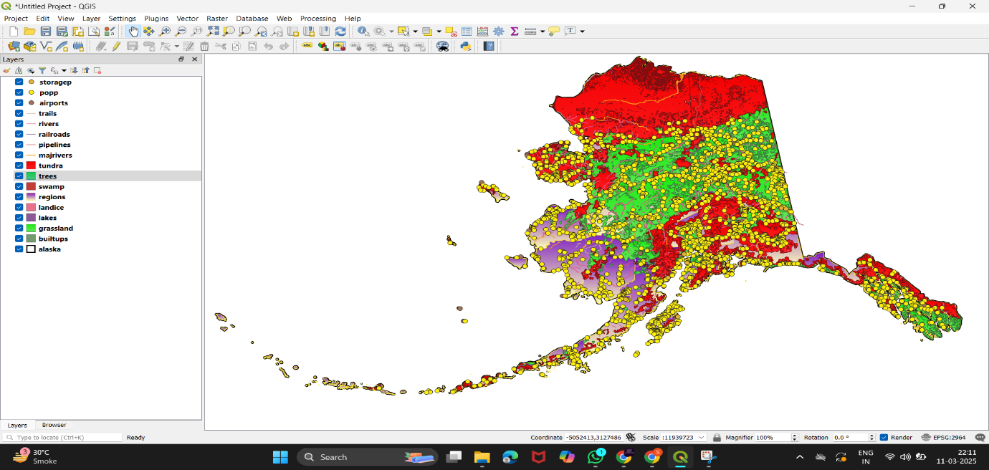

* Now lets segregate only the natural places like trees , grassland and swamp areas .

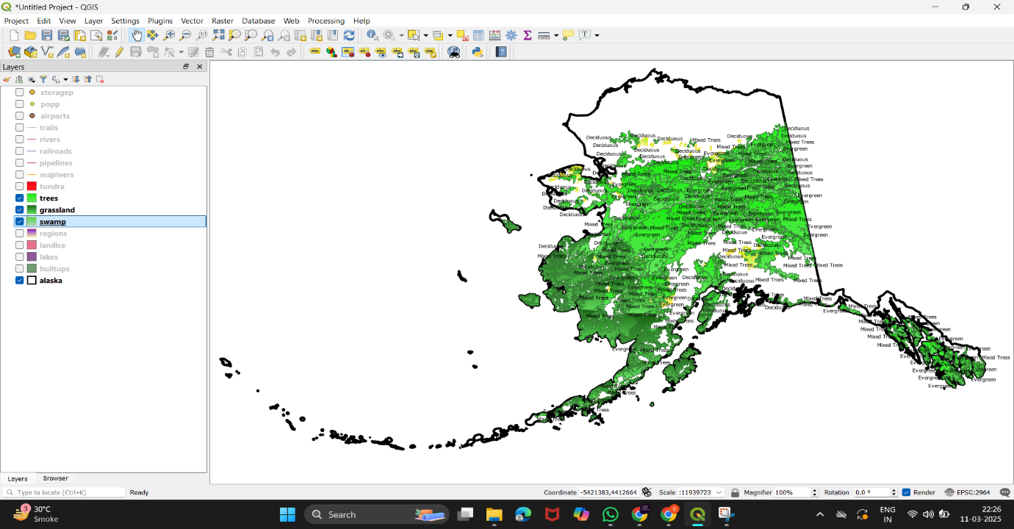

* Now open 🡪 vector 🡪 geometry tools 🡪 add geometry attributes to get the data saved on the file .

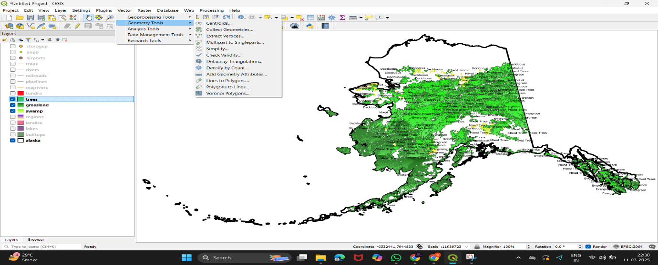

* Select 🡪 trees on input layer and save that file as trees.csv

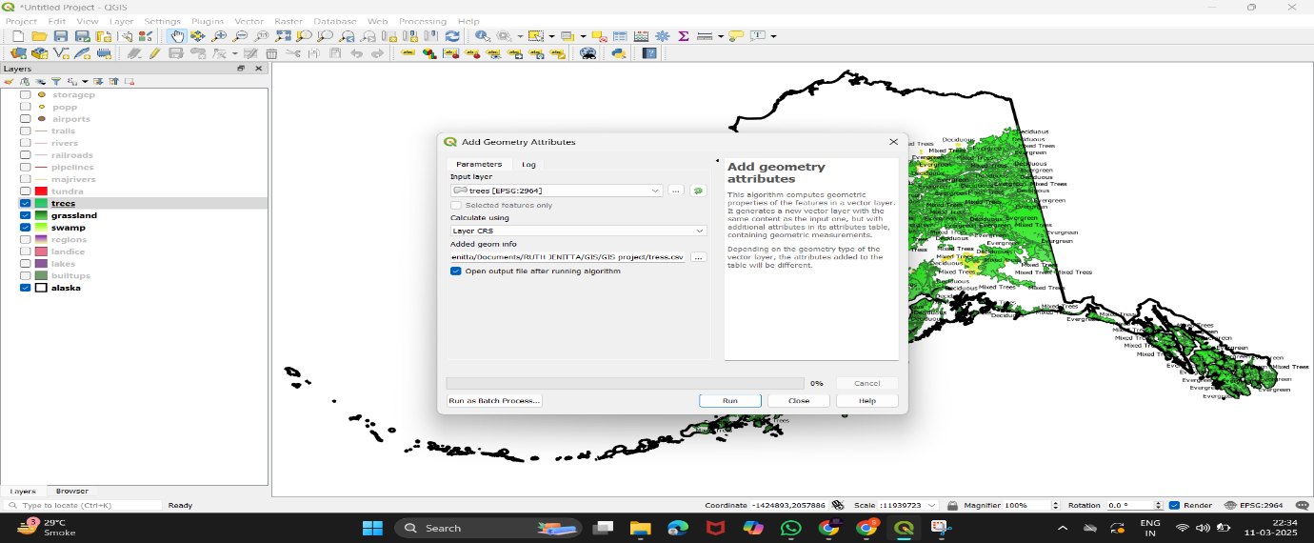

* Now open the trees.csv file and view the data

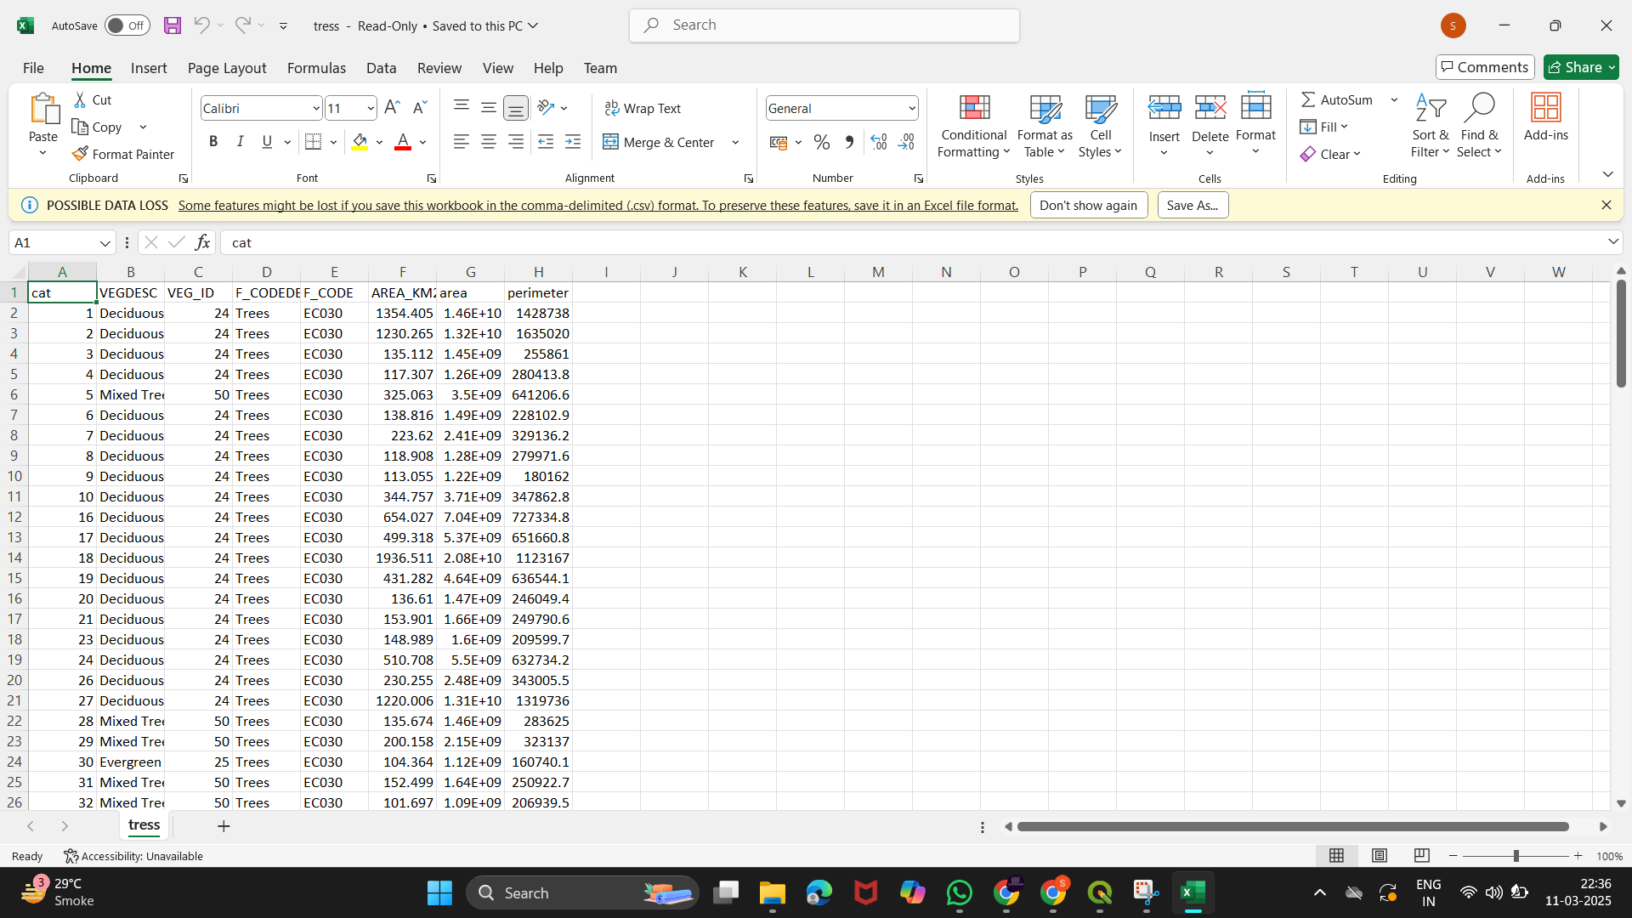

* Enable the Statistics Panel from the View Menu 🡪 Go to the View menu on the top toolbar 🡪Select Panels

From the list of panels, make sure Statistics Panel is checked.

In the panel, select the layer 🡪 trees and then choose the field you want to calculate statistics for, such as AREA_KM2.

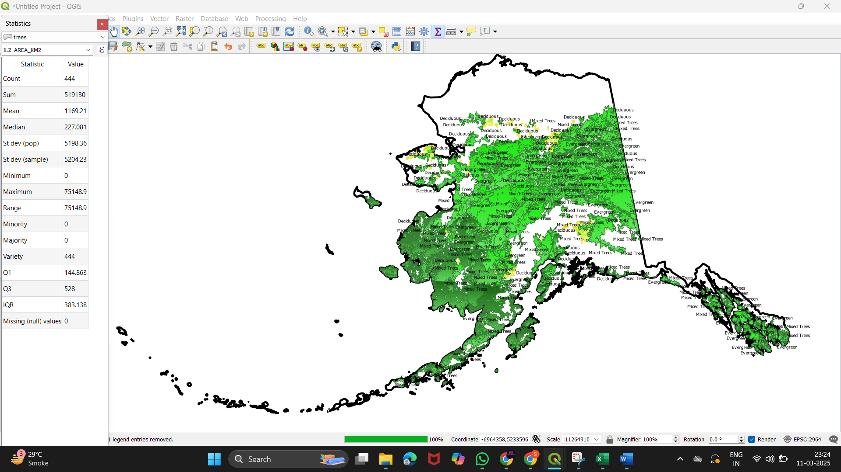

* Now in same way we can find the statistics of other areas

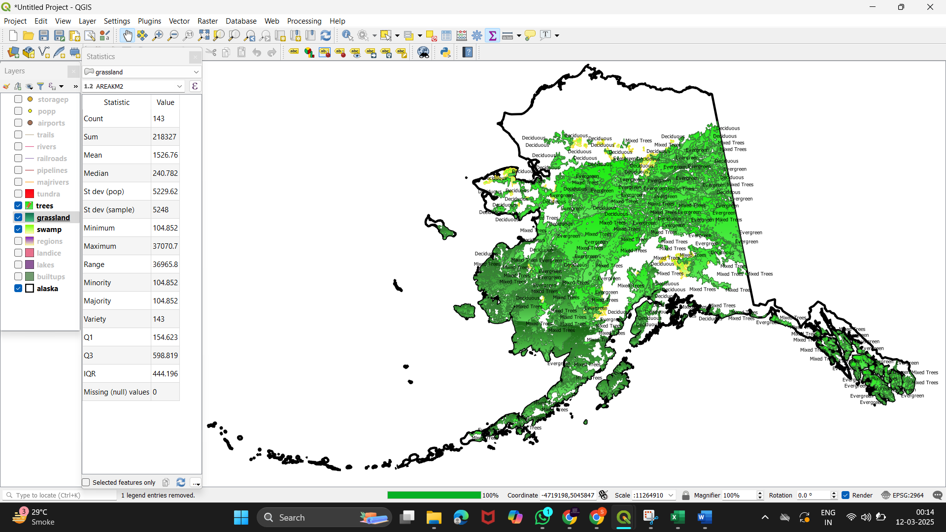

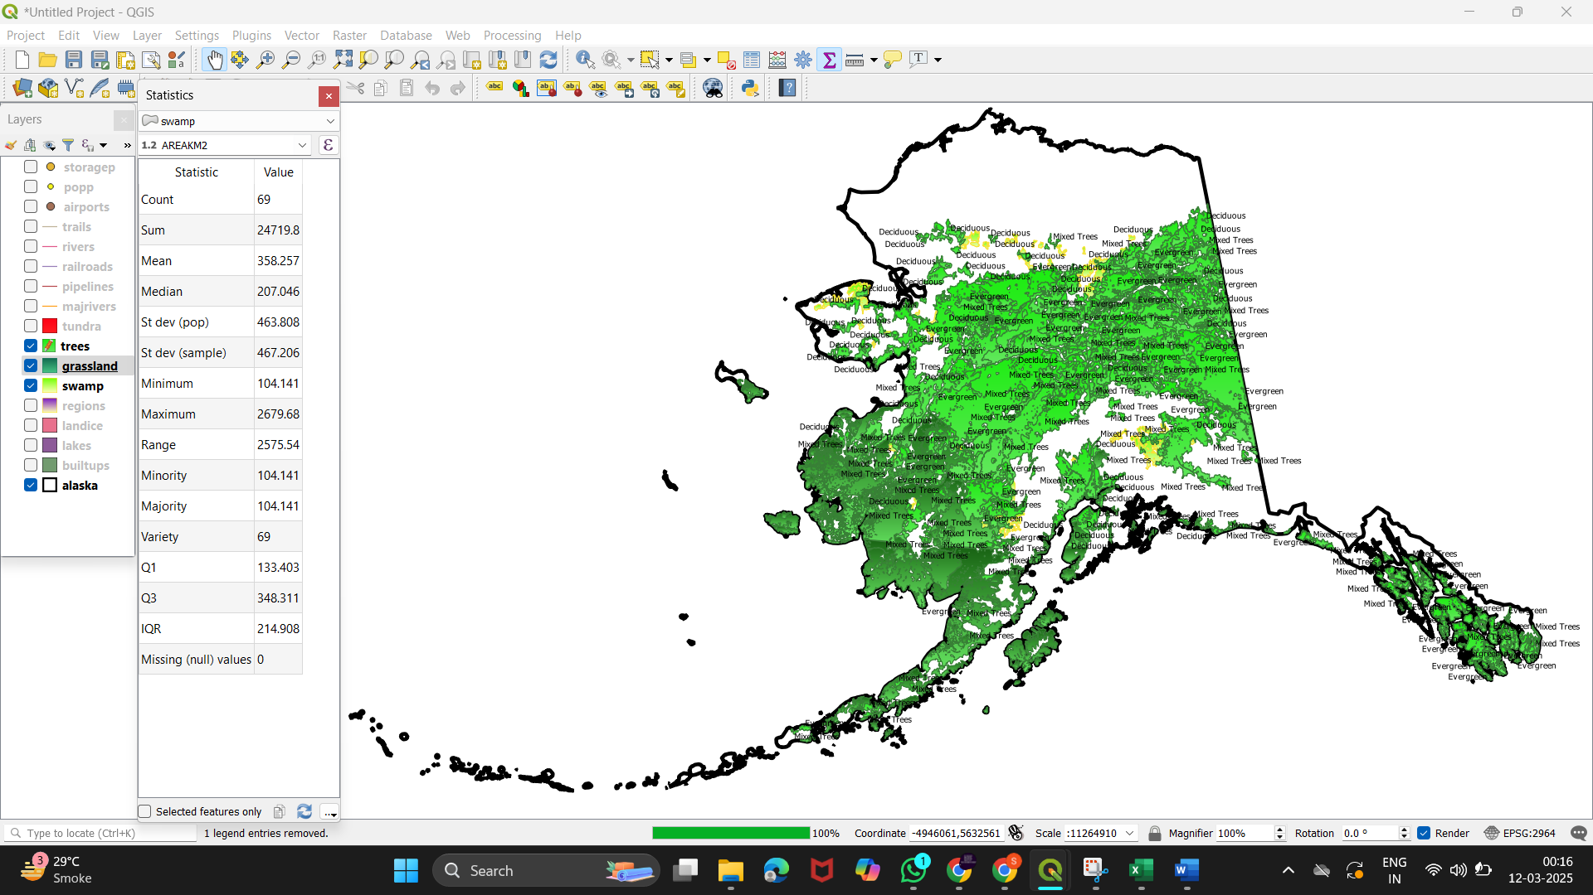

2 ) Creating visualizations :

* Creating thematic maps with color gradients to represent different data attributes (e.g., area, perimeter)
* Open the Layer Properties 🡪 Right-click on trees 🡪 Properties

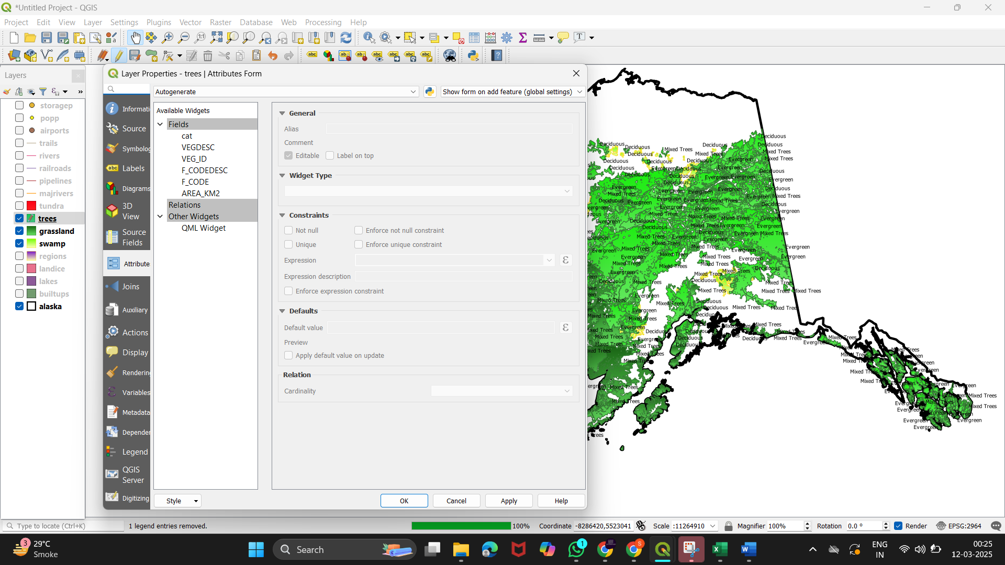

* Symbology 🡪 Graduated 🡪 Select Attribute and Color Ramp 🡪 Classify and Apply

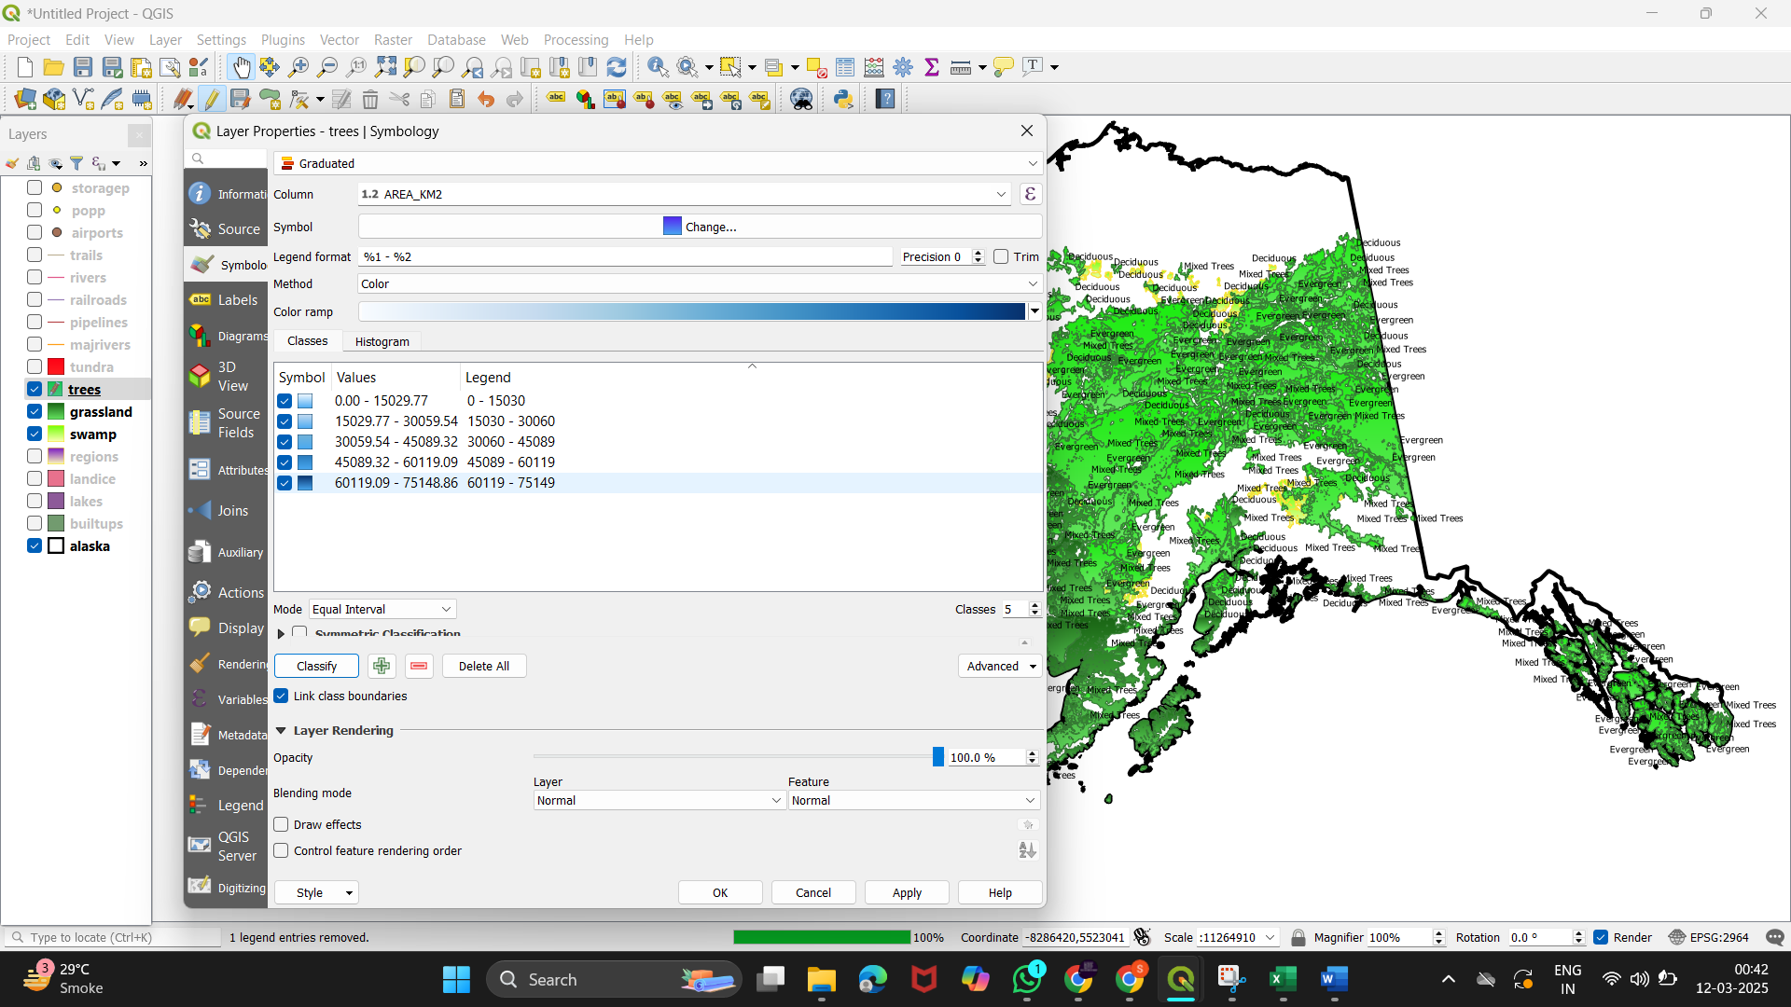

* After Applying

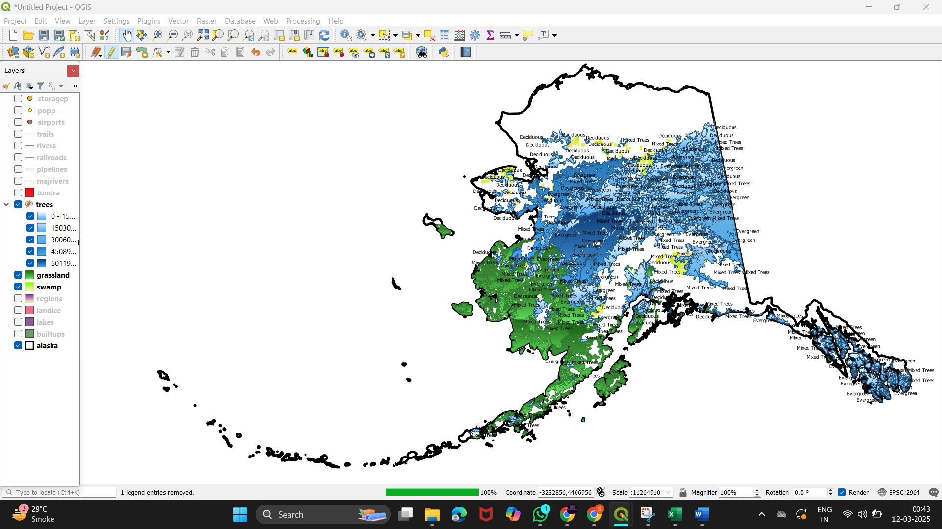

* Applied on grasslands

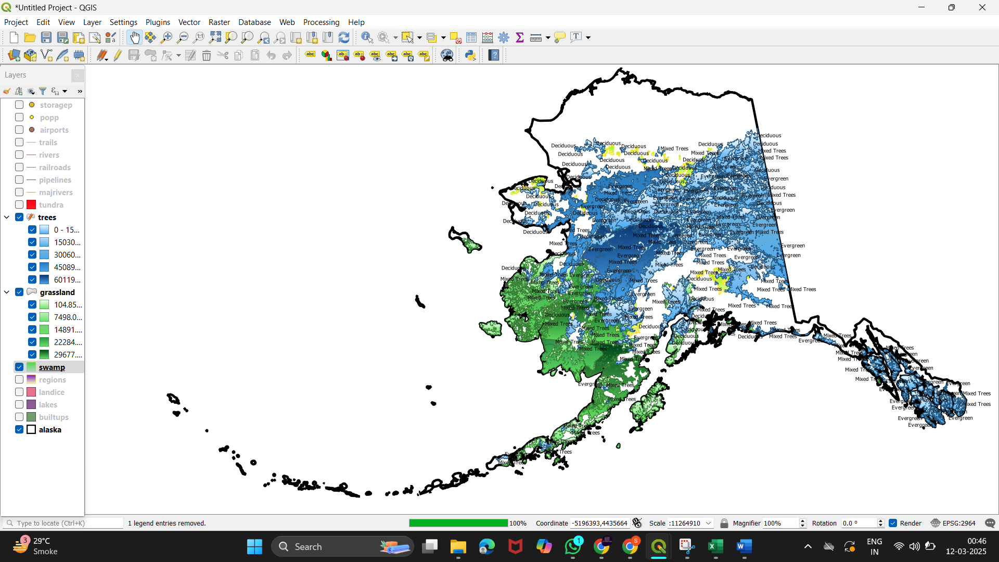

* Applied on Swamps

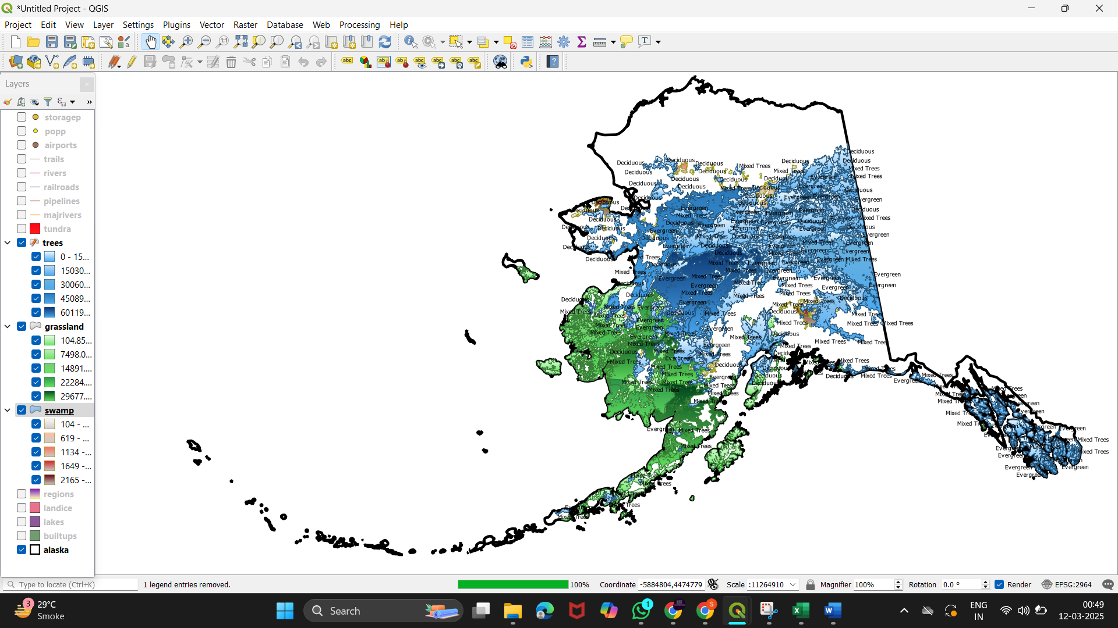

3 ) Exporting the Data for Future Use :

* Select the Layer to Export 🡪Layers panel right-click the layer you want to export (e.g., "trees" or the analyzed layer 🡪 Export 🡪 Save Features As

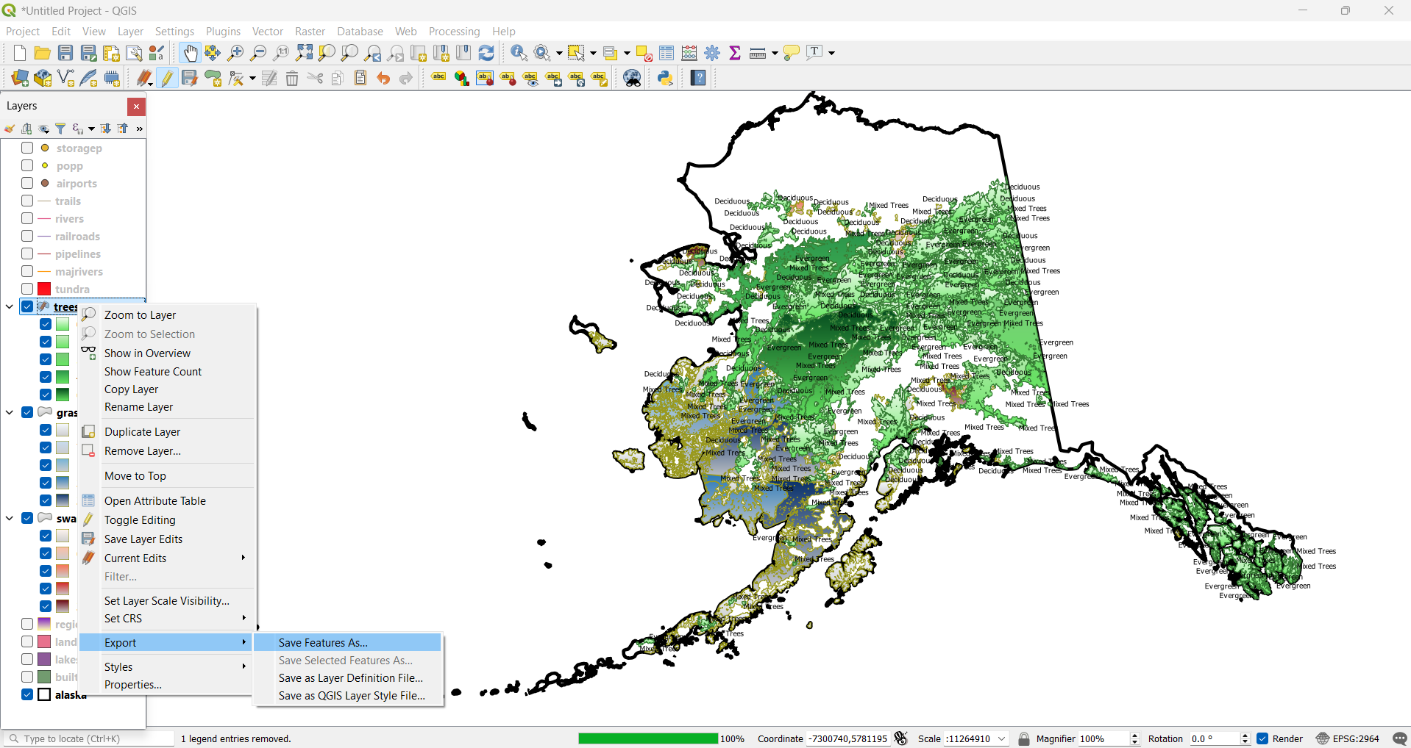

Choose File Format 🡪 ESRI Shapefile for standard GIS data or CSV based on your need.

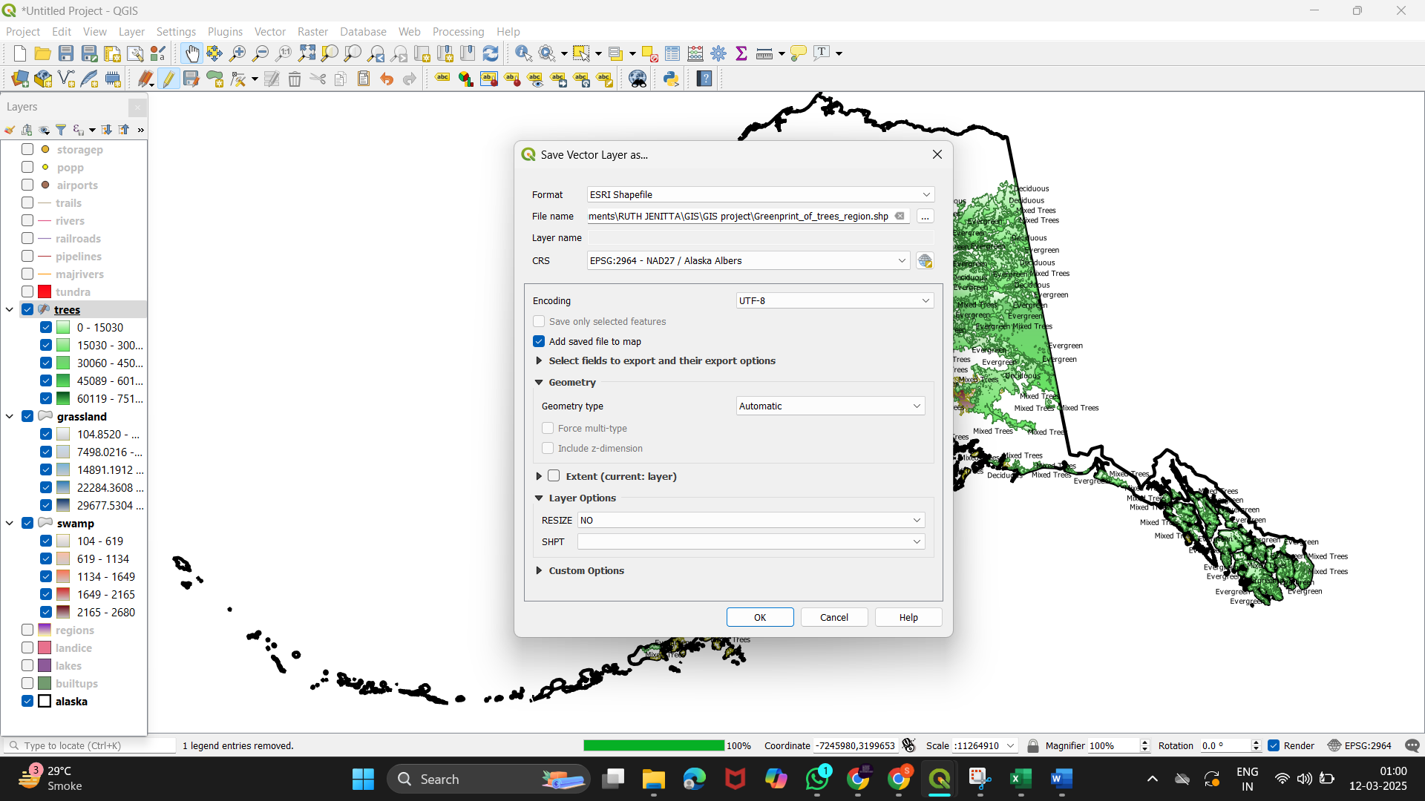

* Now lets export the grassland data’s in .CSV format

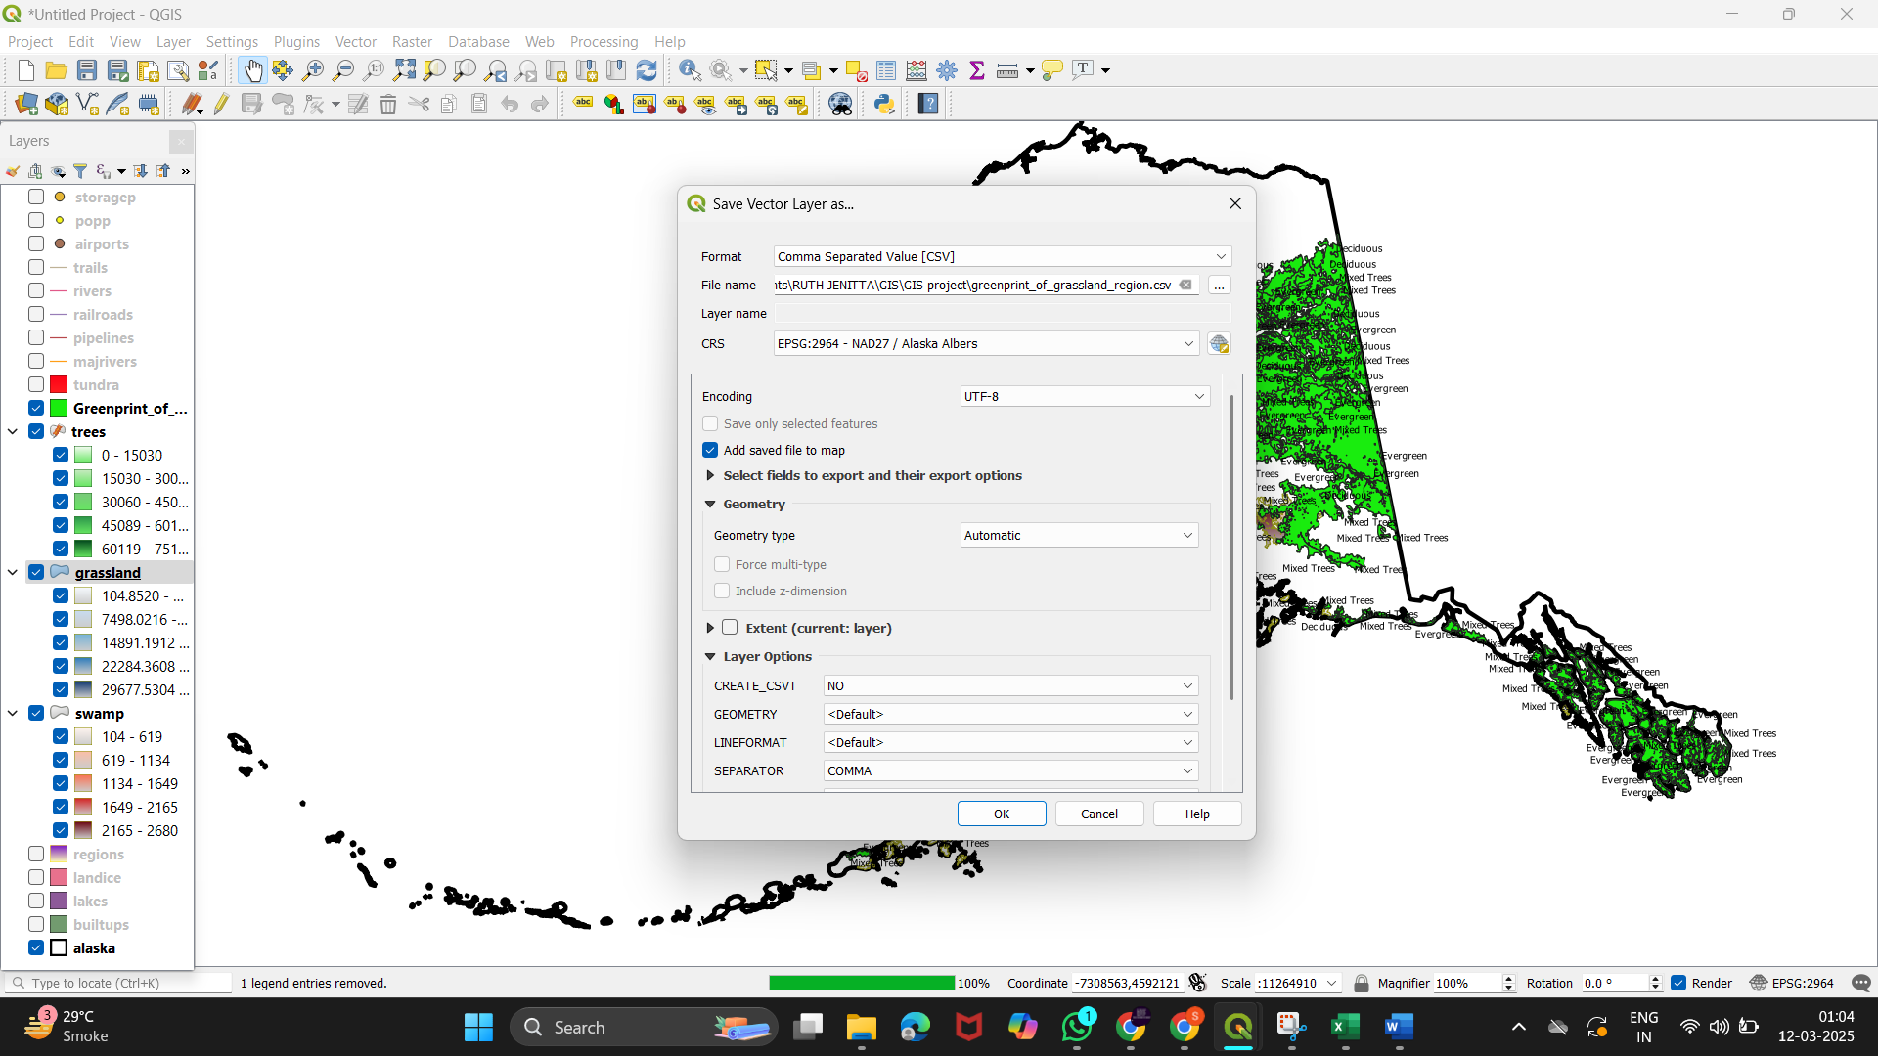

* Click ok 🡪 open file

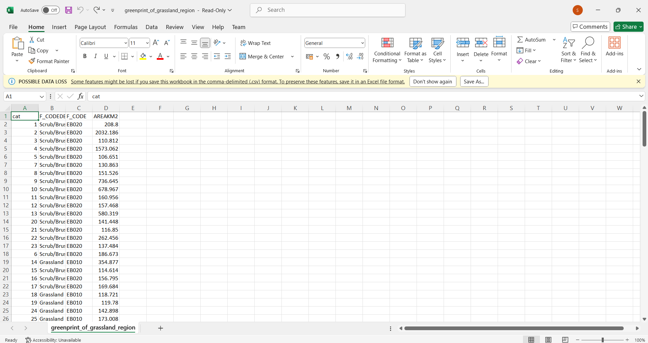

* Now lets export the swamp layer as GEO package

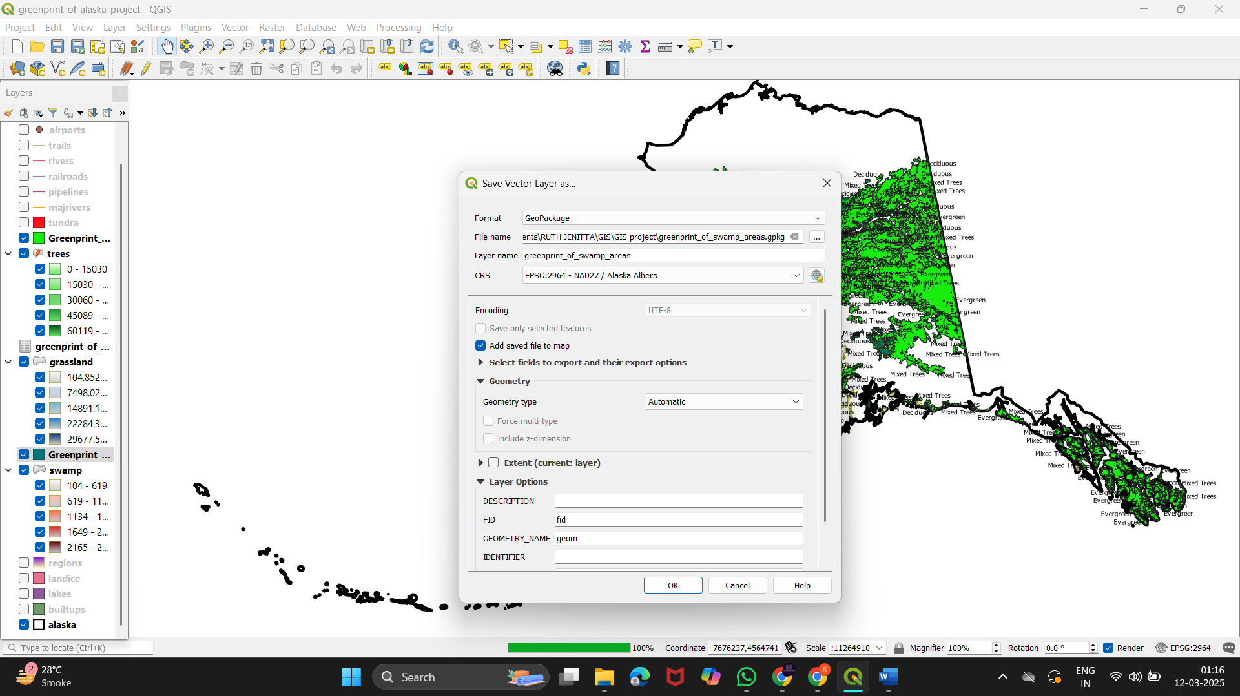

* Click ok

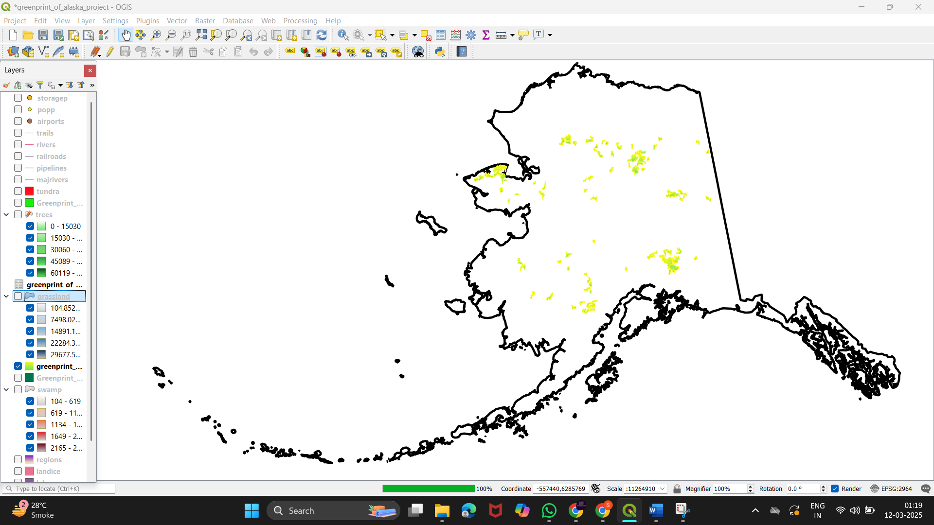

4 ) Performing Additional Operations :

a) Buffering -

Buffering helps create buffer zones around features such as trees or green spaces, allowing you to analyze areas within a certain distance from them.

* Select the layer you want to buffer "trees" 🡪 Go to the Vector menu > GeoprocessingTools > Buffer.

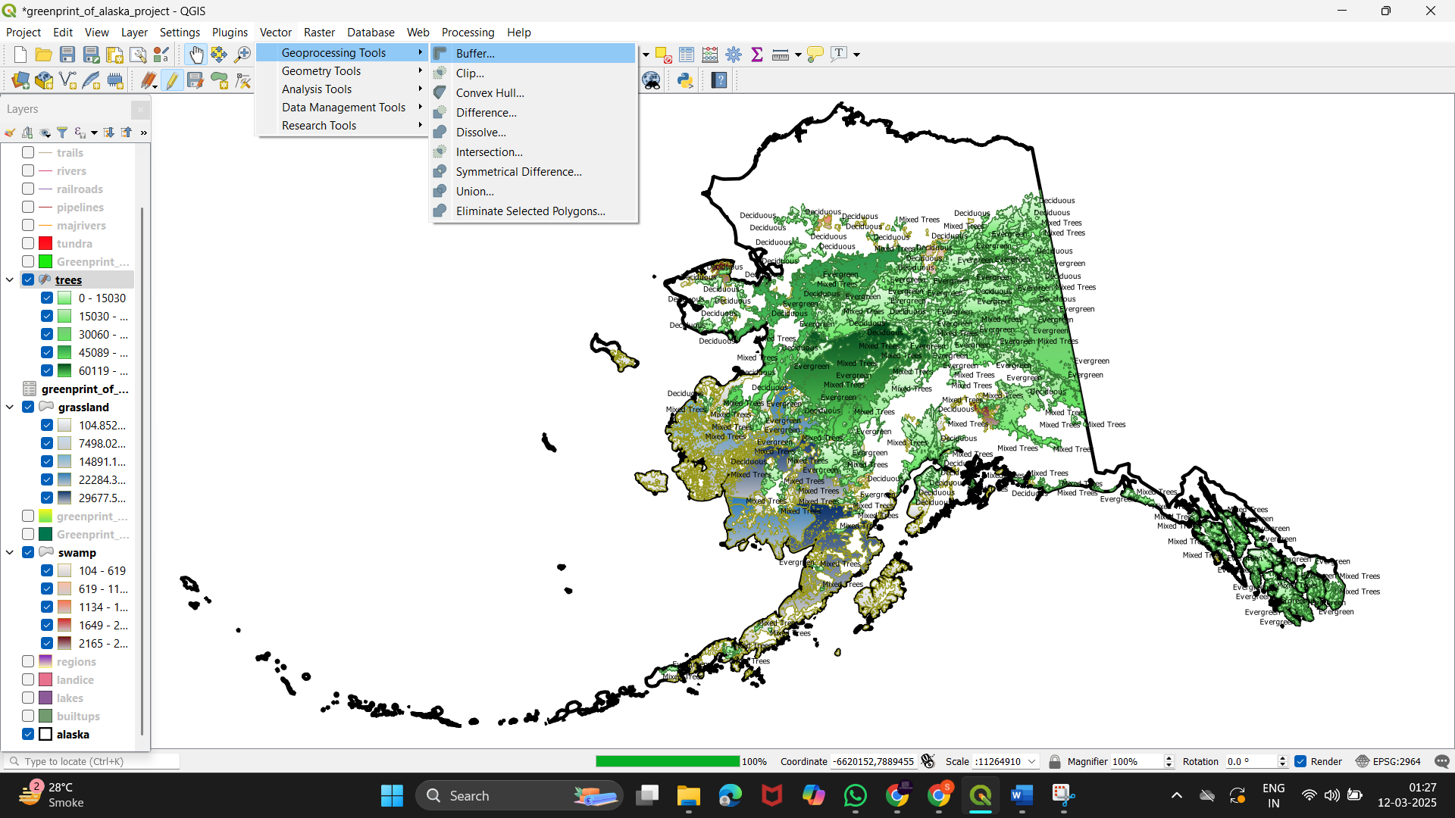

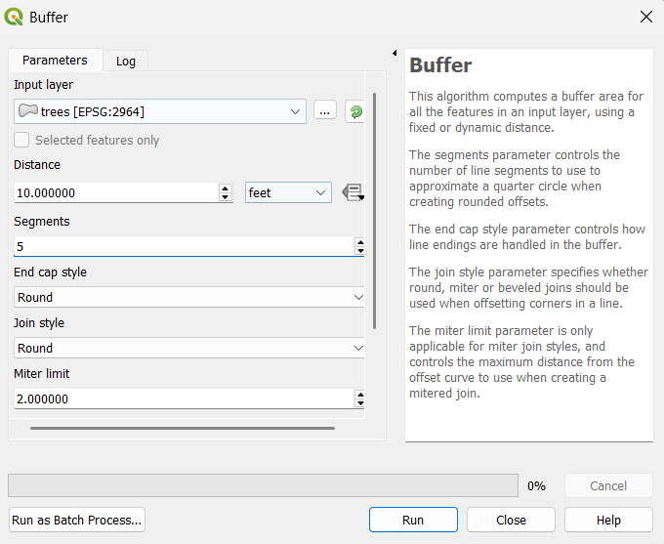

* Click on run

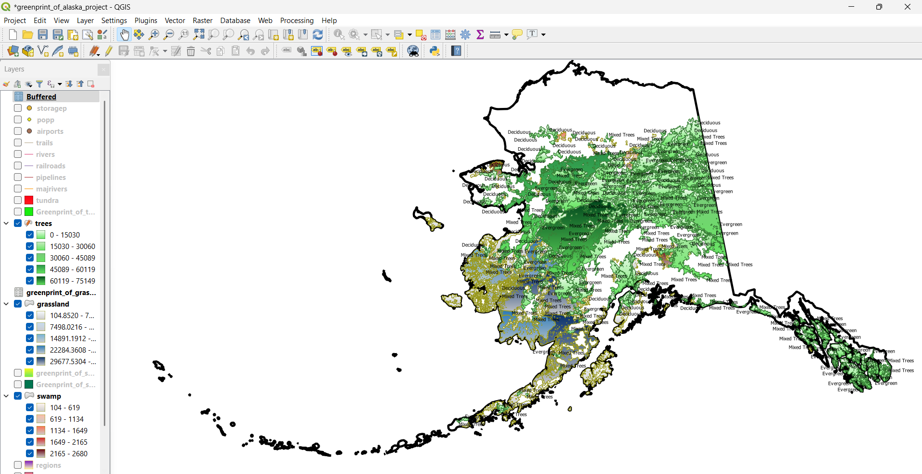

b) Clustering :

Clustering groups features together based on their spatial proximity or attribute similarity, revealing patterns within the data. We can use DBSCAN (Density-Based Spatial Clustering of Applications with Noise) algorithm or K-means Clustering

1. DBSCAN Clustering:

* Go to Processing >Toolbox or click on the gear icon on the toolbar to open the Processing Toolbox.

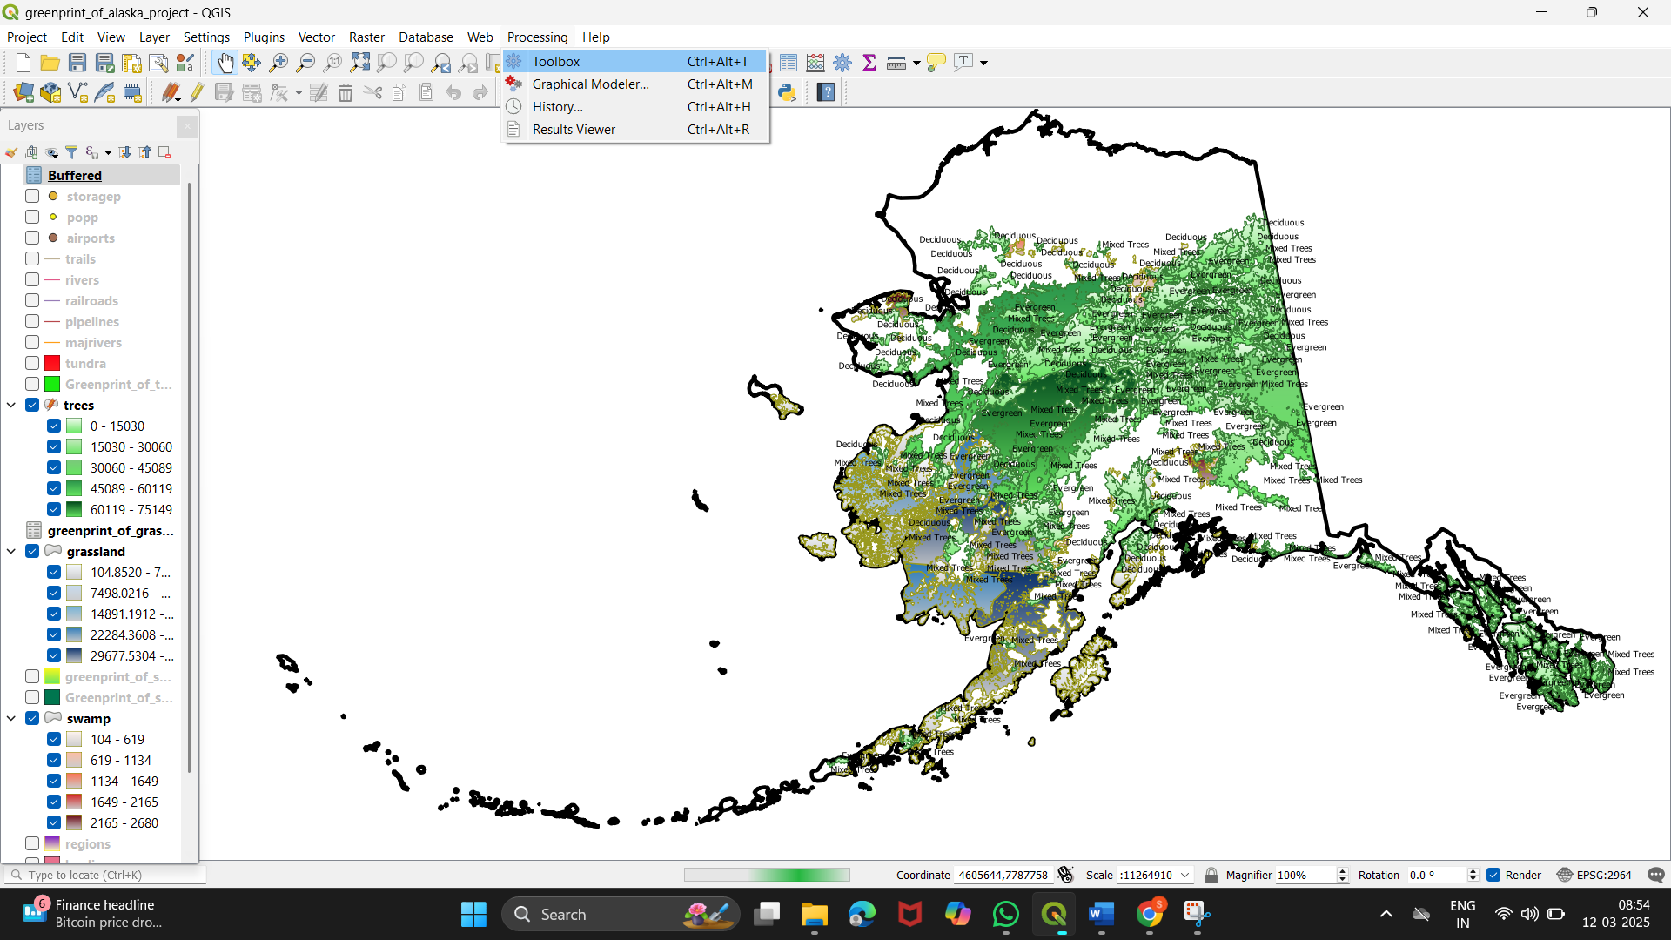

* In the Processing Toolbox, search for "DBSCAN" in the search bar

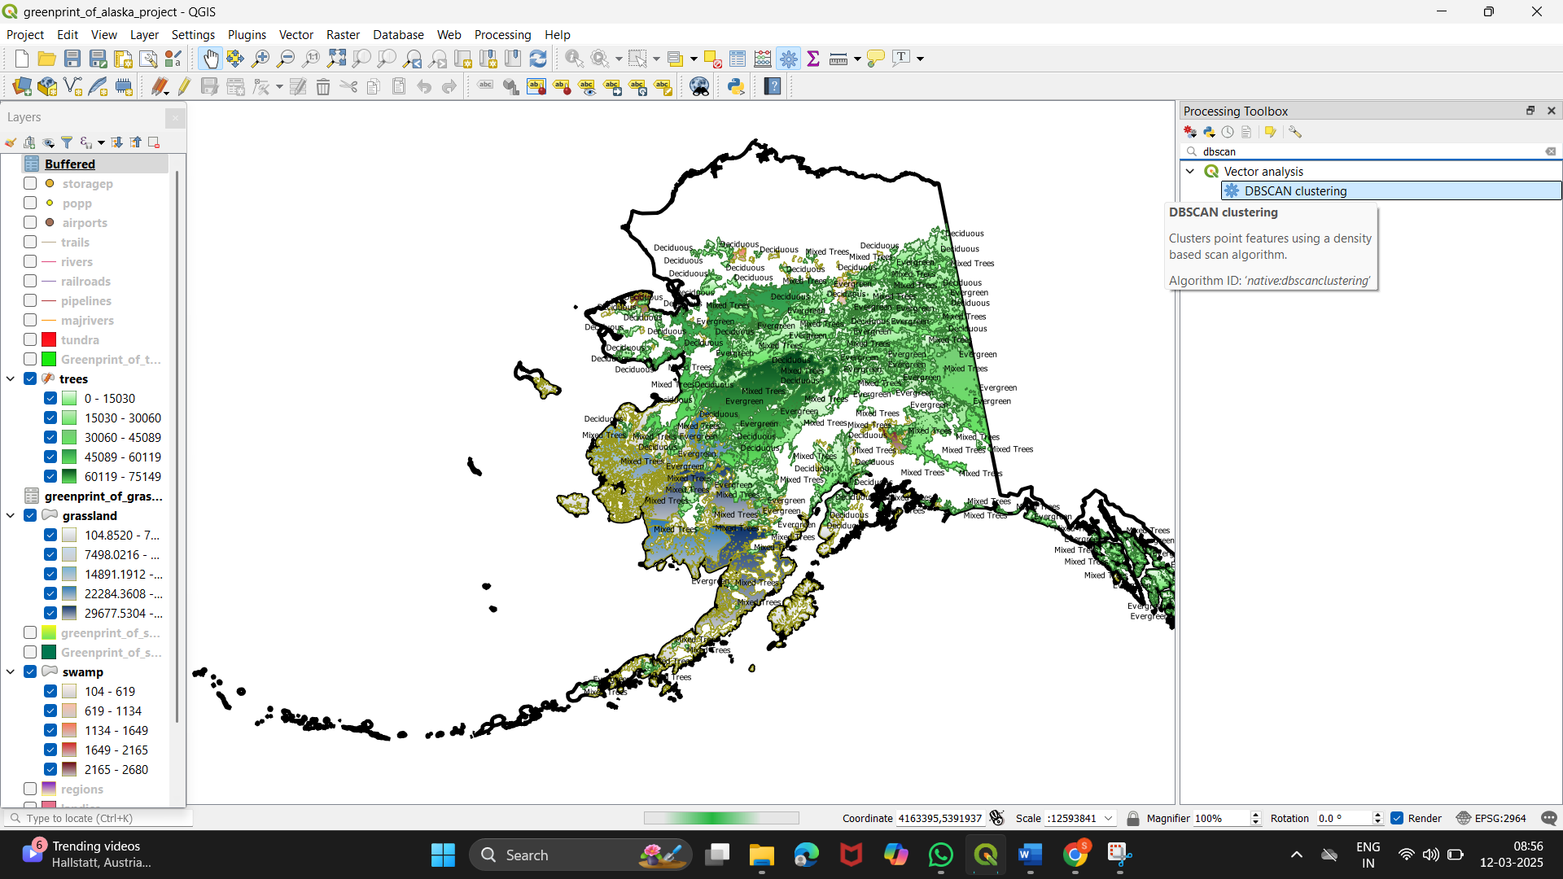

* Set DBSCAN Parameters

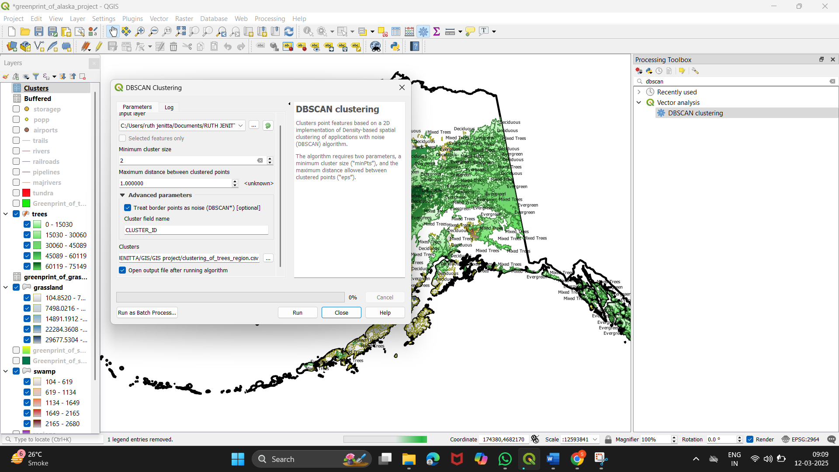

* Clustered data has been displayed

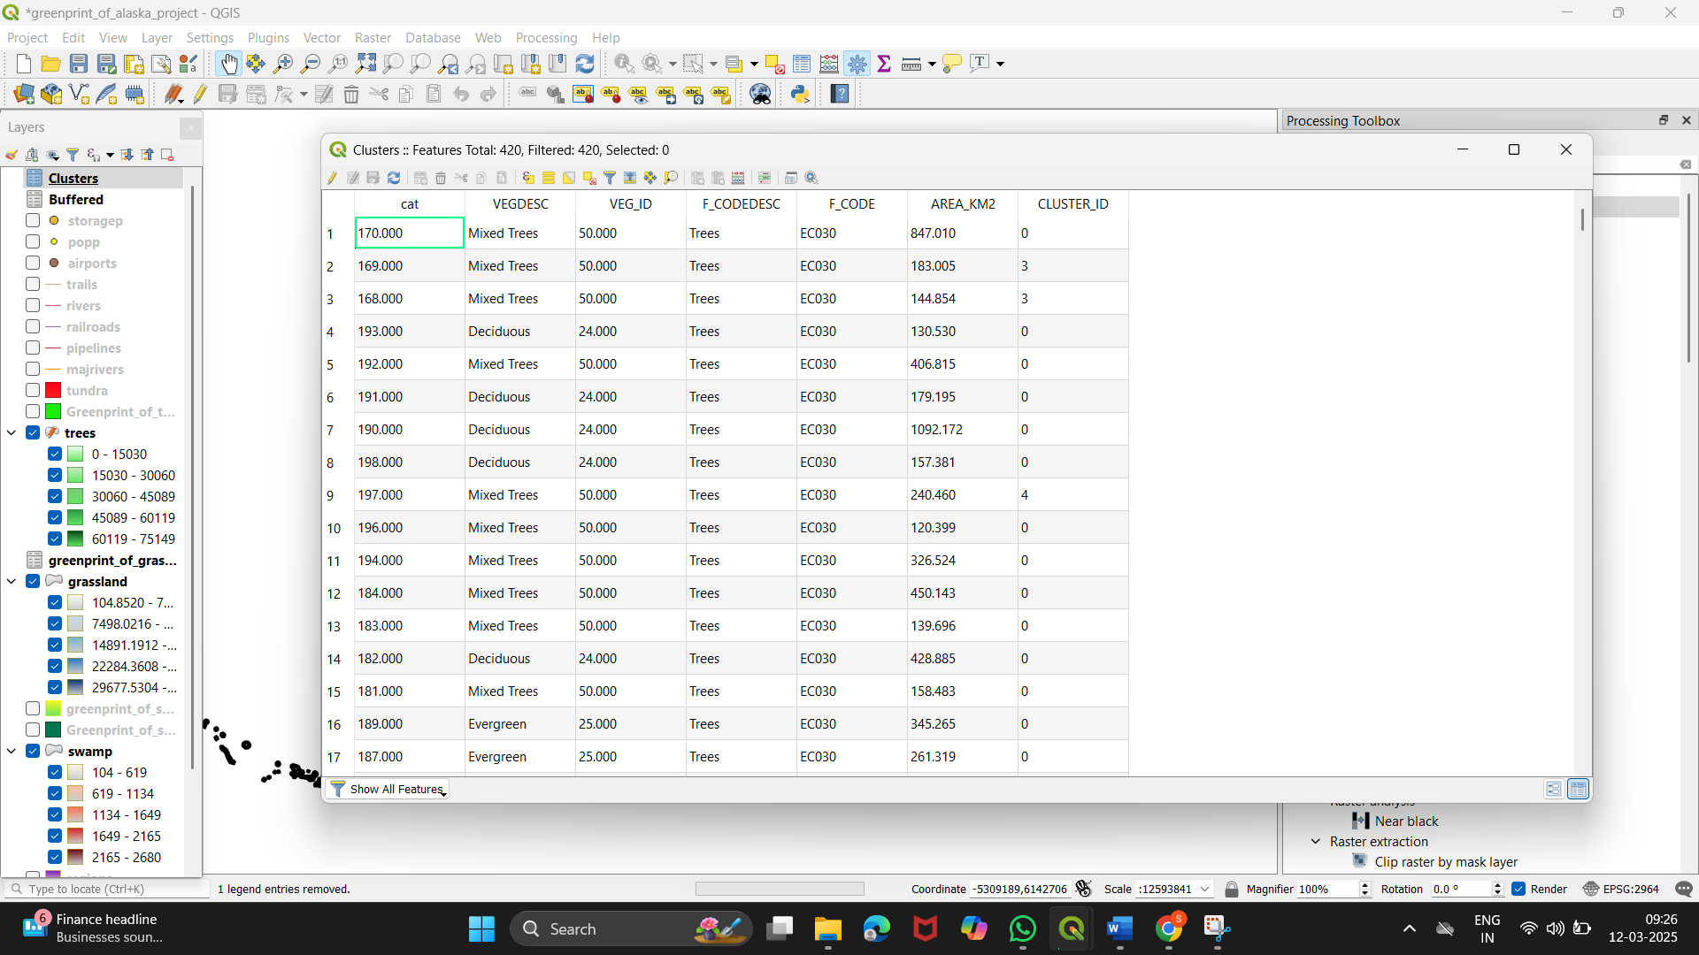

c) Filtering :

Filtering allows you to focus on specific features that meet certain criteria, such as areas above a certain size or specific tree species.

* Open the Attribute Table

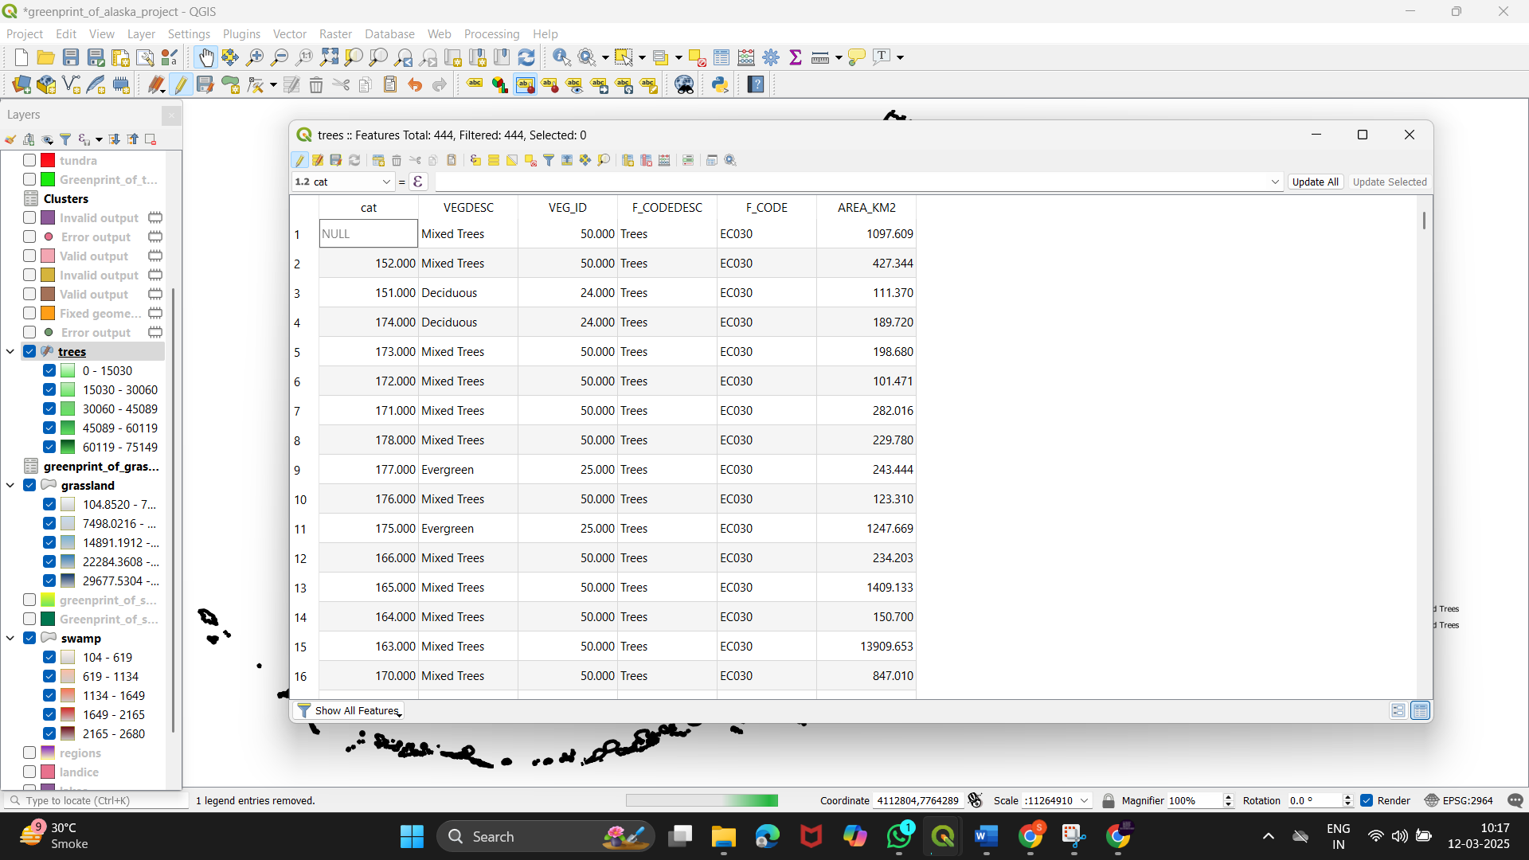

* Create a Query 🡪 "VEGDESC" = 'Deciduous' 🡪 select Select features

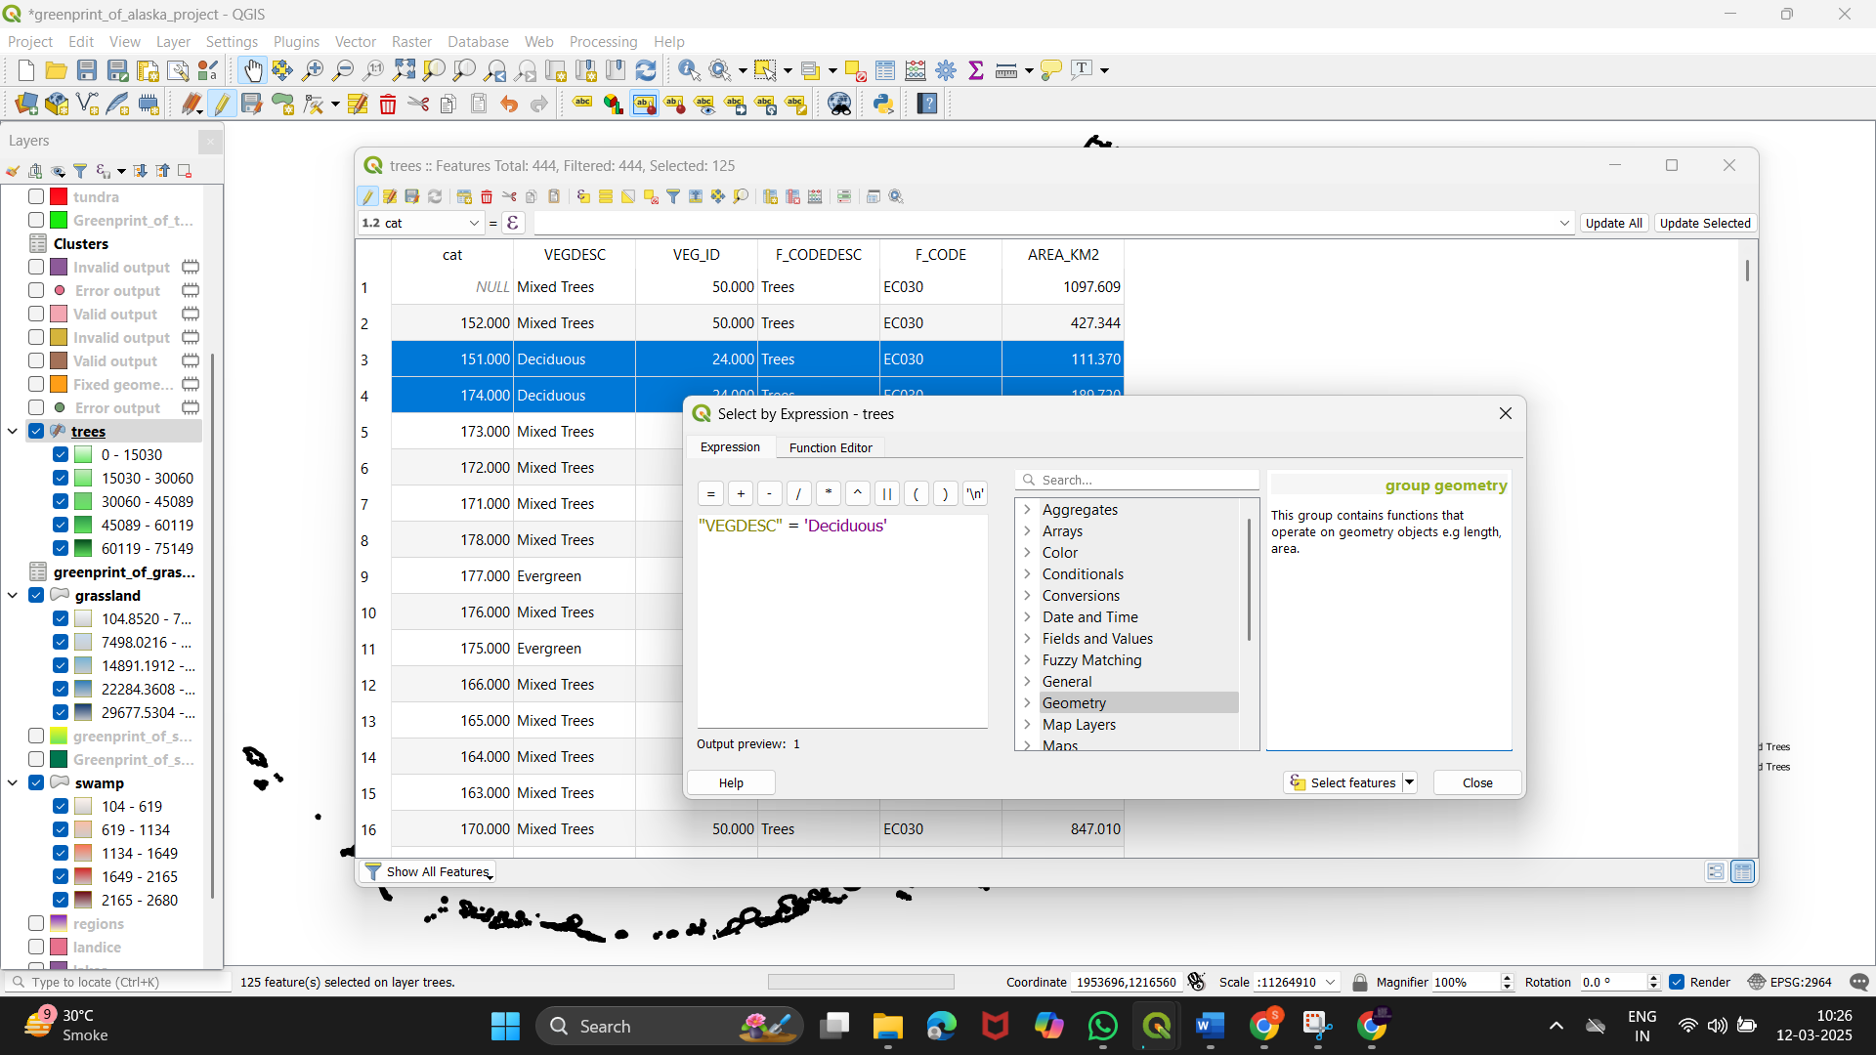

* Select the filtered region and export it

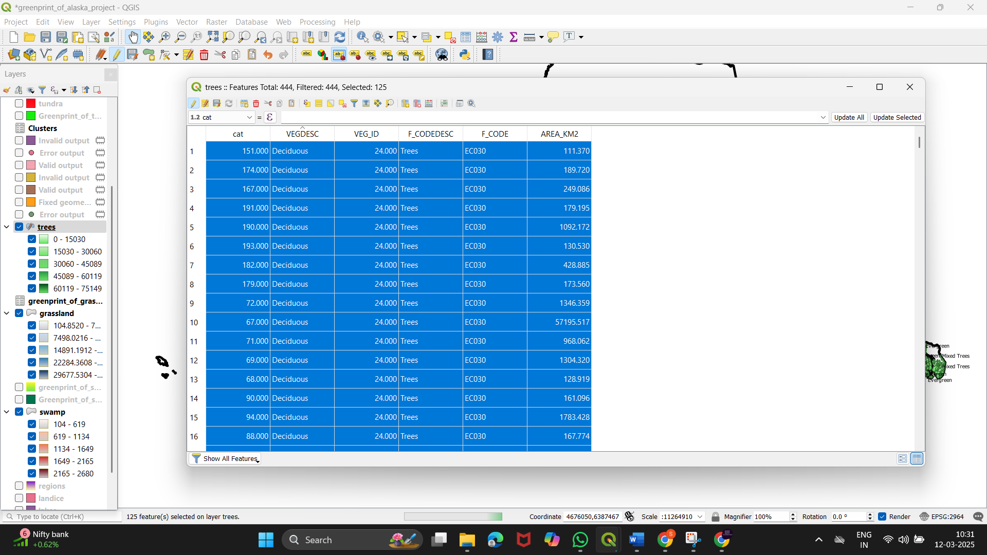

* Fill the format in which to save

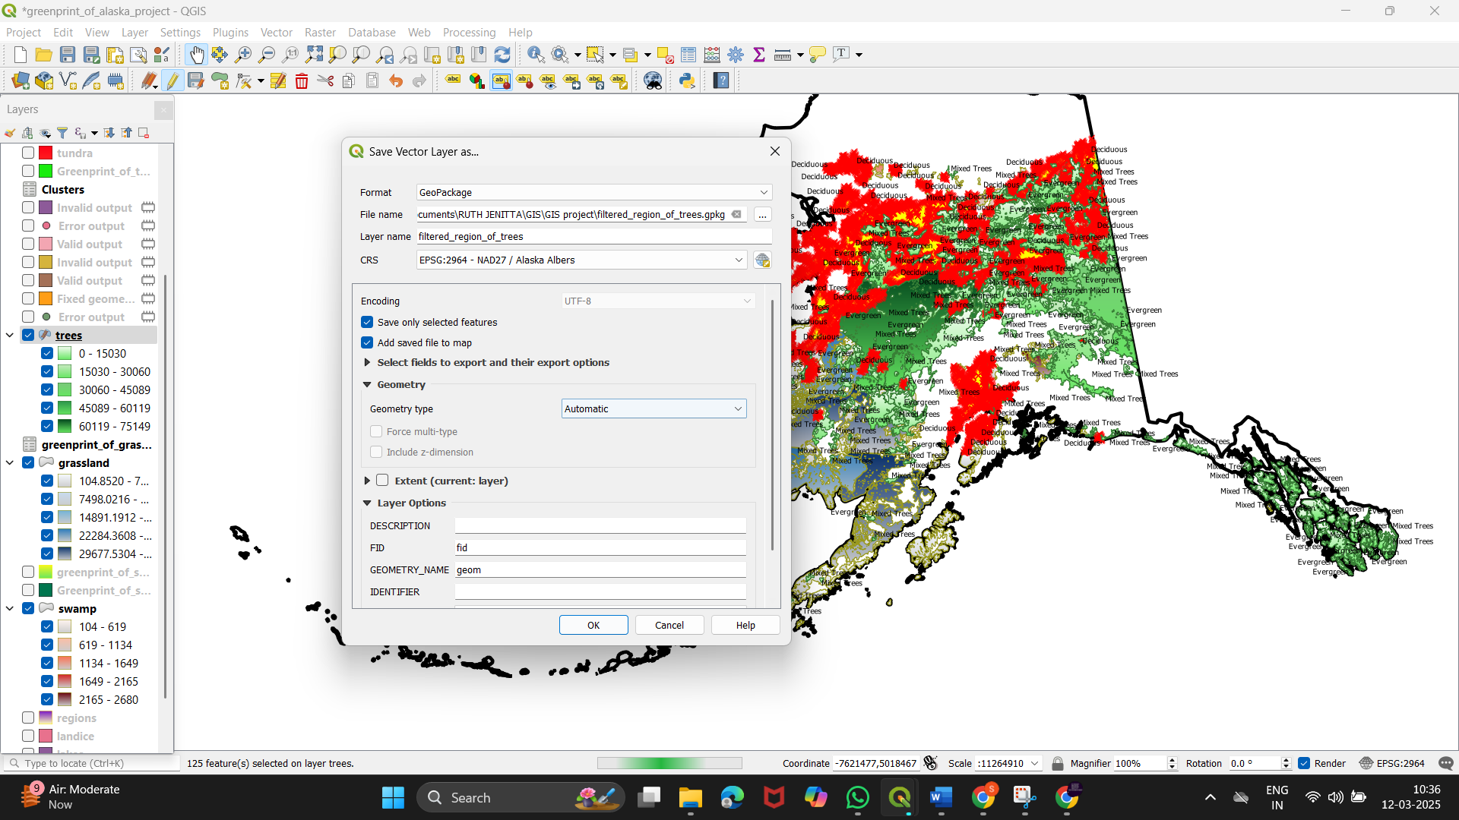

* Here’s the filtered deciduous region

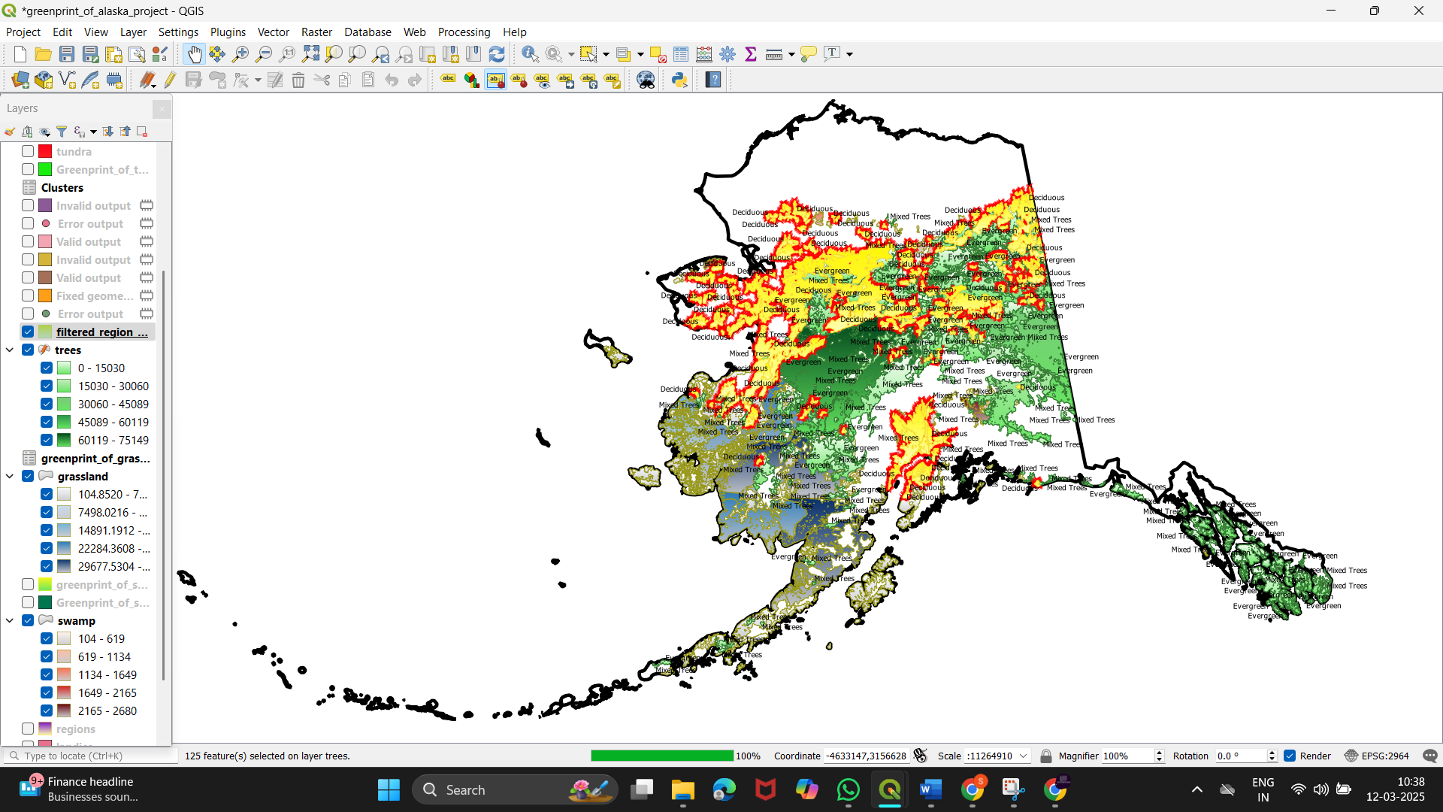

**Final output :**

* It has the greenprint of the Alaska region which has been analysed in detail.

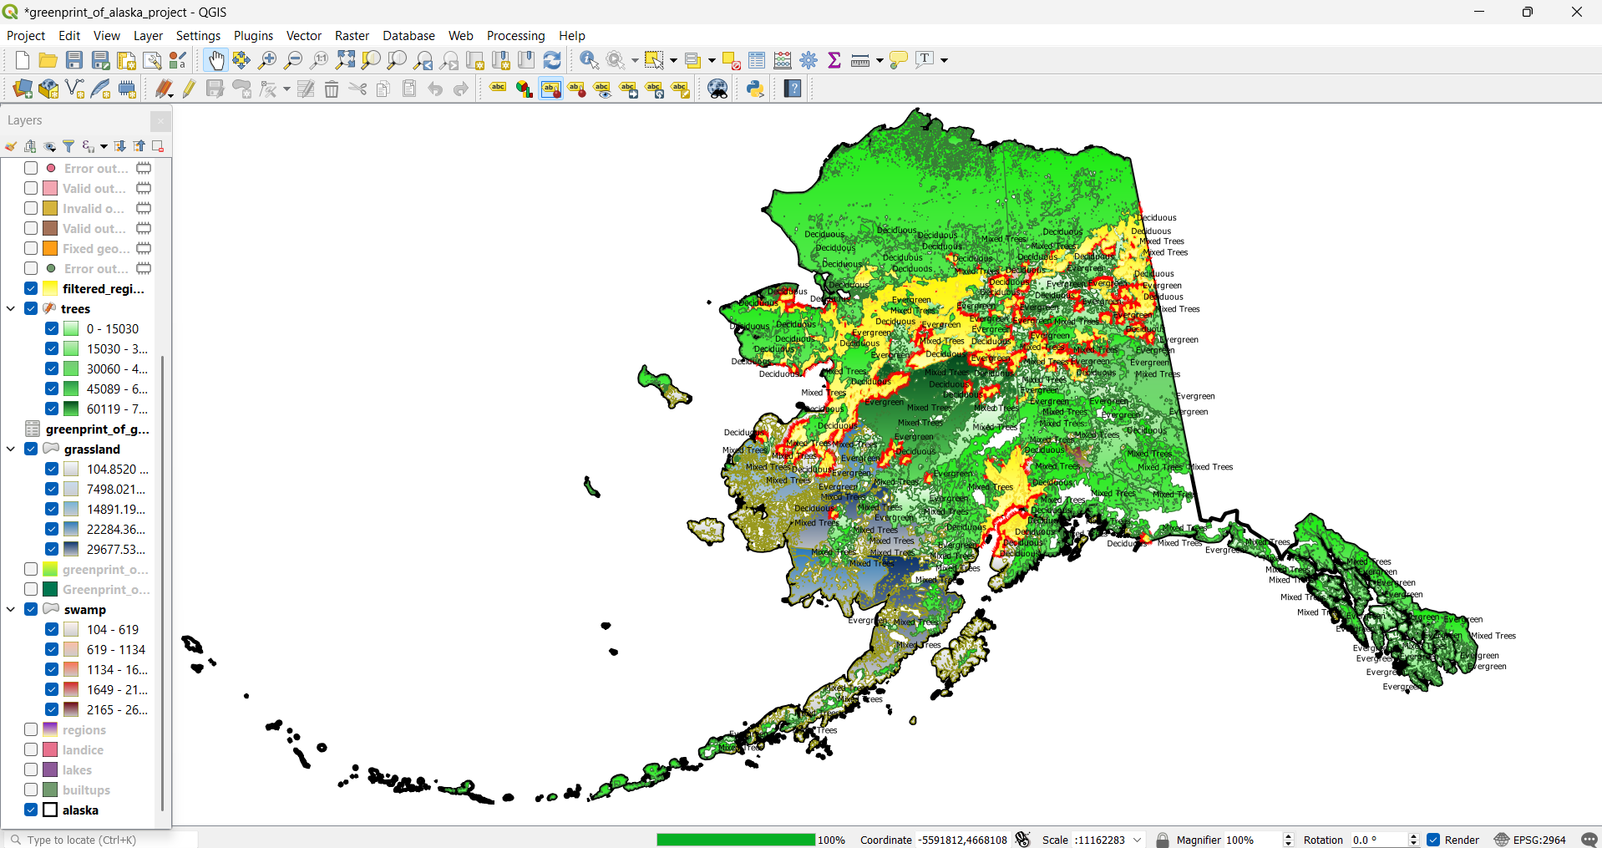

**References:**

* QGIS Development Team. (2023). *QGIS Geographic Information System*. Open Source Geospatial Foundation Project. Available at: <https://qgis.org/>
* Alaska Department of Natural Resources. (2023). *Alaska Vegetation Data Sets*. Available at: http://dnr.alaska.gov/
* US Geological Survey. (2022). *USGS Alaska Land Cover*. Available at: <https://www.usgs.gov/>
* NASA Earth Data. (2022). *MODIS Land Cover Type Data*. Available at: <https://earthdata.nasa.gov/>
* OpenStreetMap Contributors. (2023). *OpenStreetMap Data for Alaska*. Available at: <https://www.openstreetmap.org/>

**Datasets used :**

* Alaska Vegetation Dataset  
  Provided detailed information on vegetation types such as deciduous, evergreen, and mixed trees for different regions in Alaska.
* USGS Alaska Land Cover Dataset  
  A comprehensive dataset from the U.S. Geological Survey (USGS), covering land cover classifications including forest areas, grasslands, swamps, and other ecological zones.
* NASA MODIS Land Cover Data  
  MODIS (Moderate Resolution Imaging Spectroradiometer) provided satellite-based land cover data, useful for large-scale vegetation and land cover analysis across Alaska.
* OpenStreetMap (OSM) Geospatial Data  
  Used for mapping geographical features like roads, rivers, and infrastructure within the Alaska region for better context in nature mapping.
* Digital Elevation Model (DEM)

Elevation data used to understand the topographical variation across different regions of Alaska, which helped in understanding vegetation distribution.

**Conclusion :**

The Greenprint project for Alaska successfully mapped and analyzed the region's diverse vegetation and land cover, highlighting the distribution of deciduous, evergreen, and mixed forests. The use of various geospatial datasets provided insights into ecological patterns across the landscape. This project serves as a foundation for future conservation efforts and sustainable land-use planning in Alaska.